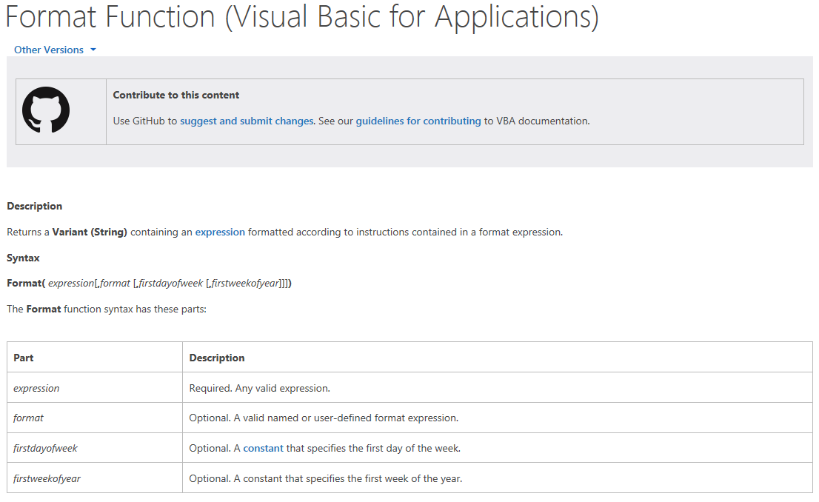

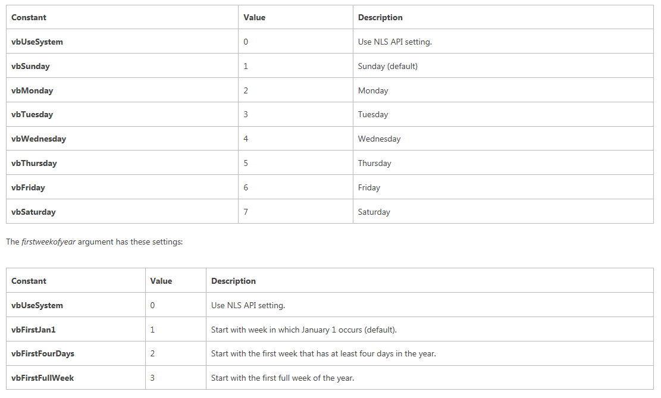

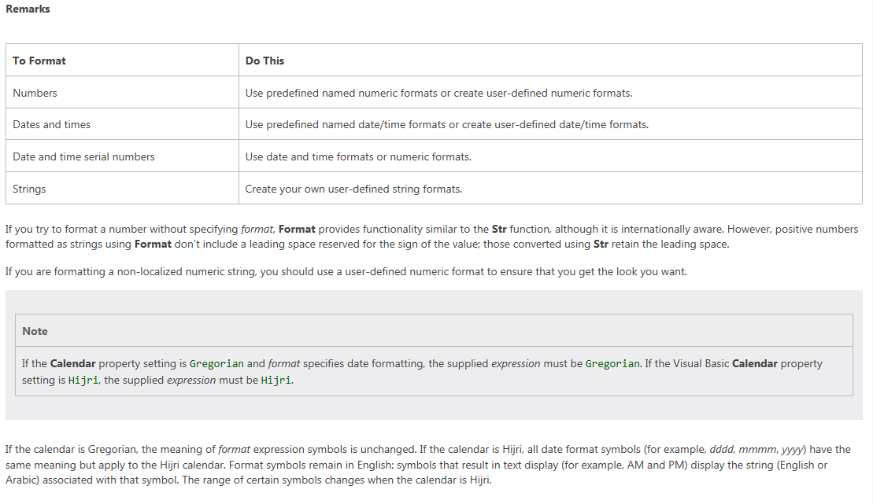

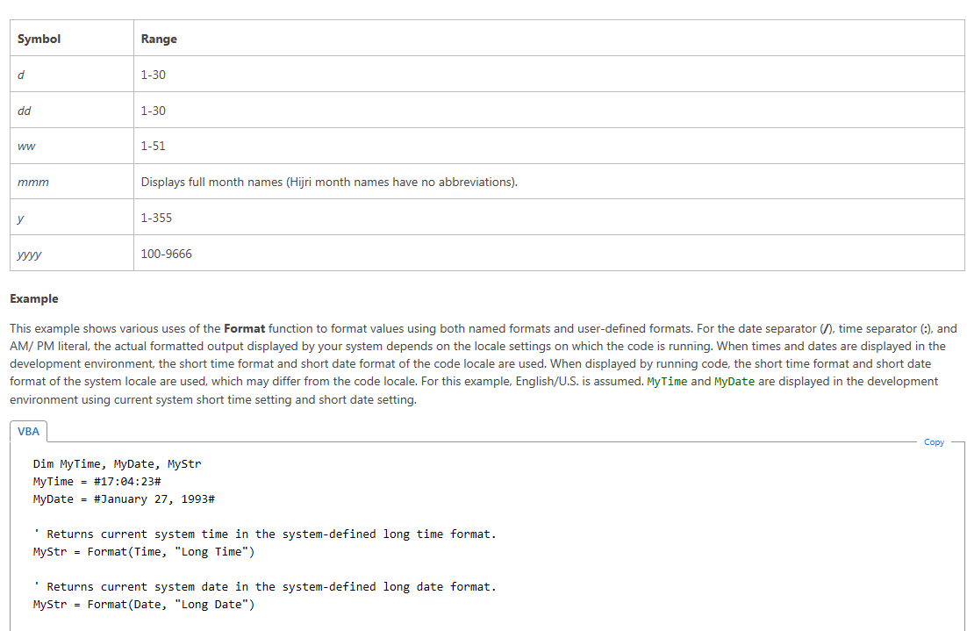

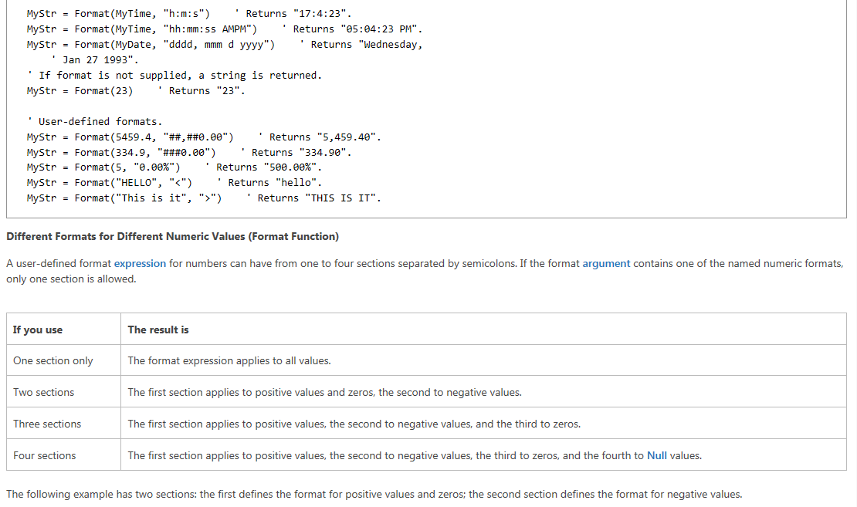

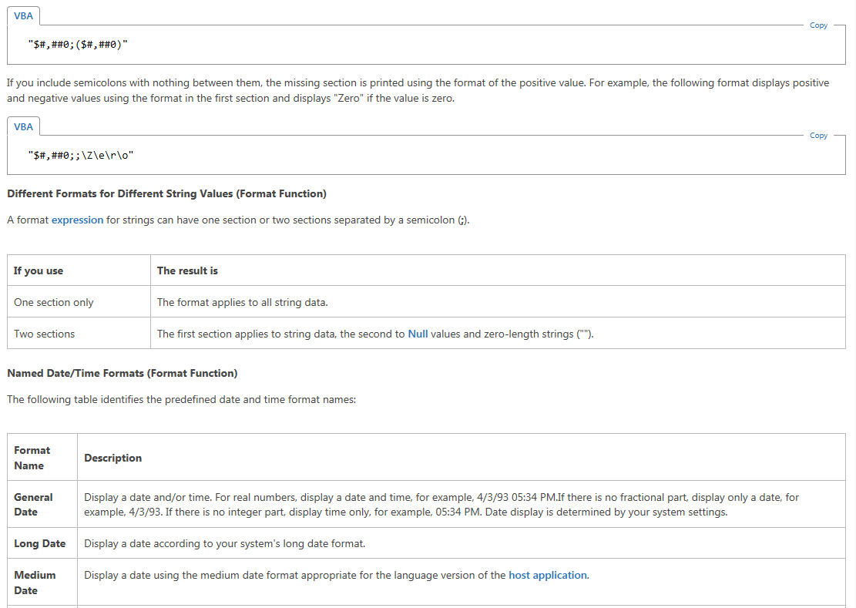

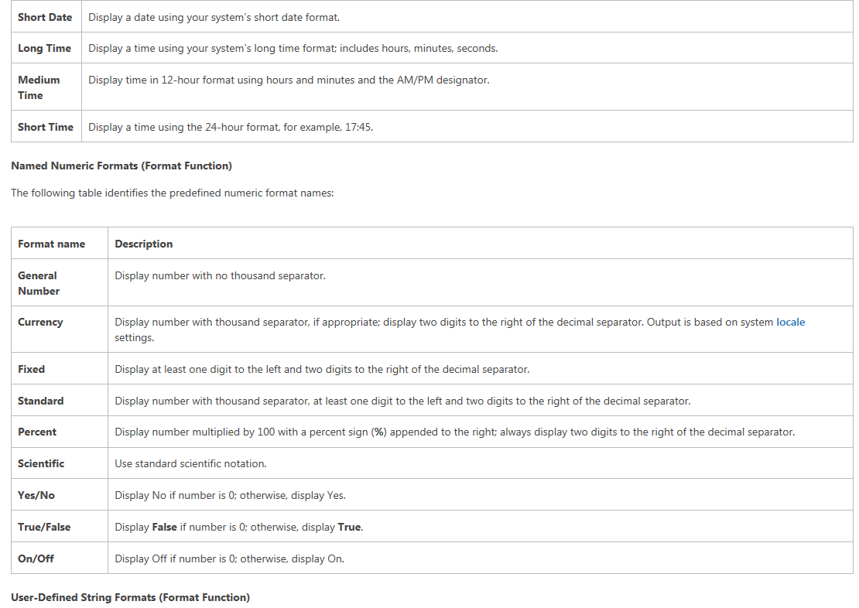

Description: Machine generated alternative text: User-Defined String Formats (Format Function) You can use any of the following characters to create a format expression for strings: Character Description Character placeholder. Display a character or a space. If the string has a character in the position where the at symbol (@) appears in the format string, display it otherwise, display a space in that position. Placeholders are filled from right to left unless there is an exclamation point character (!) in the format string. Character placeholder. Display a character or nothing. If the string has a character in the position where the ampersand (&) appears, display it otherwise, display nothing. Placeholders are filled from right to left unless there is an exclamation point character (!) in the format string. Force lowercase. Display all characters in lowercase format. Force uppercase. Display all characters in uppercase format. Force left to right fill of placeholders. The default is to fill placeholders from right to left. User- Defined Date/Ti me Formats (Format Function) The following table identifies characters you can use to create user-defined date/time formats: Character Description Time separator. In some locales, other characters may be used to represent the time separator. The time separator separates hours, minutes, and seconds when time values are formatted. The actual character used as the time separator in formatted output is determined by your system settings. Date separator. In some locales, other characters may be used to represent the date separator. The date separator separates the day, month, and year when date values are formatted. The actual character used as the date separator in formatted output is determined by your system settings. Display the date as ddddd and display the time as ttttt, in that order. Display only date information if there is no fractional part to the date serial number; display only time information if there is no integer portion. Display the day as a number without a leading zero (1 — 31).

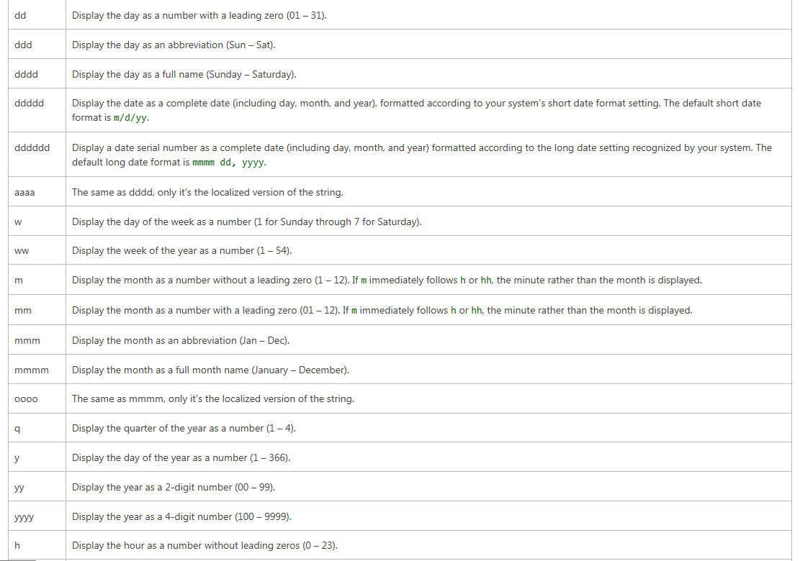

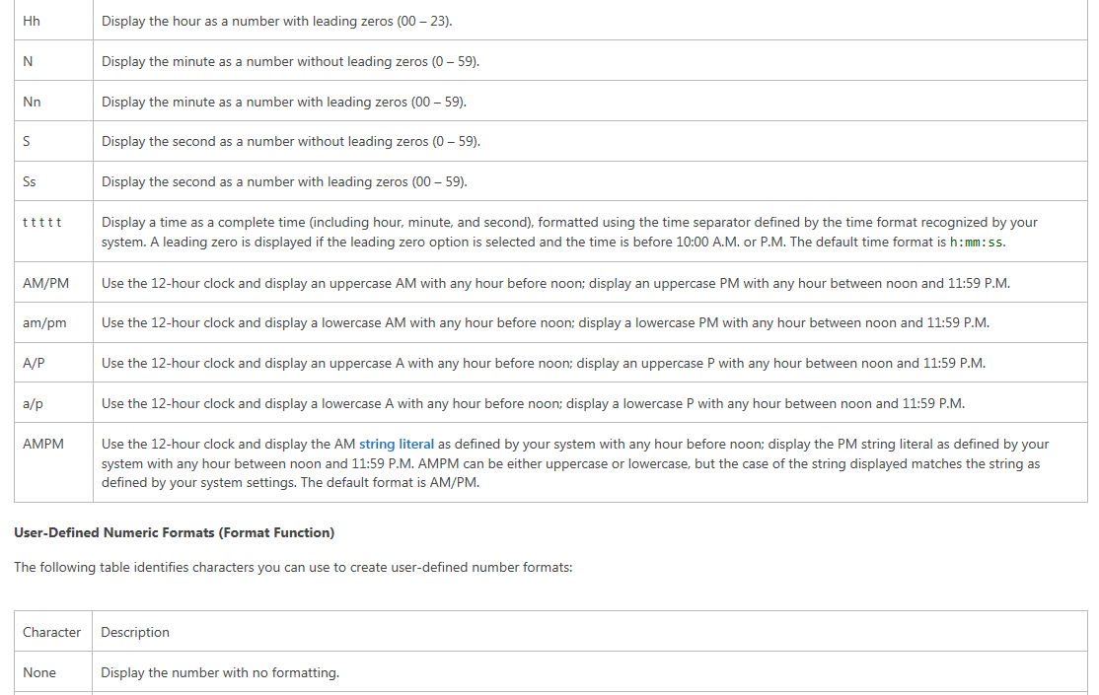

Description: Machine generated alternative text: (O) Digit placeholder. Display a digit or a zero. If the expression has a digit in the position where the O appears in the format string, display it; otherwise, display a zero in that position. If the number has fewer digits than there are zeros (on either side of the decimal) in the format expression, display leading or trailing zeros. If the number has more digits to the right of the decimal separator than there are zeros to the right of the decimal separator in the format expression, round the number to as many decimal places as there are zeros. If the number has more digits to the left of the decimal separator than there are zeros to the left of the decimal separator in the format expression. display the extra digits without modification. Digit placeholder. Display a digit or nothing. If the expression has a digit in the position where the # appears in the format string, display it otherwise, display nothing in that position. This symbol works like the O digit placeholder, except that leading and trailing zeros arent displayed if the number has the same or fewer digits than there are # characters on either side of the decimal separator in the format expression. Decimal placeholder. In some locales, a comma is used as the decimal separator. The decimal placeholder determines how many digits are displayed to the left and right of the decimal separator. If the format expression contains only number signs to the left of this symbol, numbers smaller than 1 begin with a decimal separator. To display a leading zero displayed with fractional numbers, use O as the first digit placeholder to the left of the decimal separator. The actual character used as a decimal placeholder in the formatted output depends on the Number Format recognized by your system. Percentage placeholder. The expression is multiplied by 100. The percent character (%) is inserted in the position where it appears in the format string. Thousand separator. In some locales, a period is used as a thousand separator. The thousand separator separates thousands from hundreds within a number that has four or more places to the left of the decimal separator. Standard use of the thousand separator is specified if the format contains a thousand separator surrounded by digit placeholders (O or #). Two adjacent thousand separators or a thousand separator immediately to the left of the decimal separator (whether or not a decimal is specified) means ‘scale the number by dividing it by 1000, rounding as needed.” For example, you can use the format string “##O,,” to represent 100 million as 100. Numbers smaller than 1 million are displayed as 0. Two adjacent thousand separators in any position other than immediately to the left of the decimal separator are treated simply as specifying the use of a thousand separator. The actual character used as the thousand separator in the formatted output depends on the Number Format recognized by your system. Time separator. In some locales, other characters may be used to represent the time separator. The time separator separates hours, minutes, and seconds when time values are formatted. The actual character used as the time separator in formatted output is determined by your system settings. Date separator. In some locales, other characters may be used to represent the date separator. The date separator separates the day. month, and year when date values are formatted. The actual character used as the date separator in formatted output is determined by your system settings.

